http://127.0.0.1:8081/createpost
request
{
"first_name": "string",
"pronoun": "string",
"last_name": "string",
"preferred_name": "string",
"student_id": 0,
"course": "string",
"intake": "Fall",
"year": 0
}

Intake can only take in["Fall", "January", "May"]
first_name: str
pronoun: str
last_name:str
preferred_name: str
student_id : int
course: str
intake: Literal["Fall", "January", "May"]
year: int

Response
{
"data": {
"student_id": 0,
"first_name": "string",
"last_name": "string",
"full_name": "string string",
"preferred_name": "string",
"audio_binary": "\\xfff344c400118001dc014100010f0f0f3ff800efffffffffffffffffffffffdfffec03ff0030f0",
"pronoun": "string",
"phonetics": [],
"data_in_votes_table": false
},
"results": [],
"status": "success",
"message": ""
}

If the student_id exists then throws the below response
{
"status": "failed",
"message": "Student ID already exists"
}

If phonetics data is already exists then gets the below response
Response body
Download
{
"data": {
"student_id": 2,
"first_name": "string",
"last_name": "string",
"full_name": "string string",
"preferred_name": "string",
"audio_binary": "\\xfff344c400118001dc014100010f0f0f3ff800efffffffffffffffffffffffdfffe”,
"pronoun": "string",
"phonetics": [],
"data_in_votes_table": true
},
"results": [
{
"votes": 1,
"votes_id": 3,
"phonetic": "string",
"exist_in_phonetics_db": false,
"name": "string"
}
],
"status": "success",
"message": ""
}

http://127.0.0.1:8081/selection
{
"student_id": 0,
"name": [
"string"
],
"phonetics_selection": [
"string"
],
"audio_selection": "string",
"show": true,
"data_in_votes_table": false
}
student_id : int
name:list
phonetics_selection: list
audio_selection: str
show: bool
data_in_votes_table: bool

Response
Response body
Download
{
"status": "success",
"message": ""
}
if "data_in_votes_table": false is set to false even if result has data then api will throw an error
{"status":'failed',
"message":"Data is not present in votes table please check data_in_votes_table files in set to false"}

http://127.0.0.1:8081/getRecords/?course=2024&offset=0&limit=10

below are the fields that are required, if you are using pagination offset and limit should be sent in the query parameters
if you are using all the parameters you will be seeing the api url as below
student_id: int
first_name: str
pronoun: str
last_name:str
preferred_name: str
course: str
intake: Literal["Fall", "January", "May"]
year: int
phonetics_selection: str

http://127.0.0.1:8081/getRecords/?studentID=1&firstname=firstname&lastname=lastname&preferred_name=student&year=2024&course=AIGS&intake=Fall&offset=0&limit=10

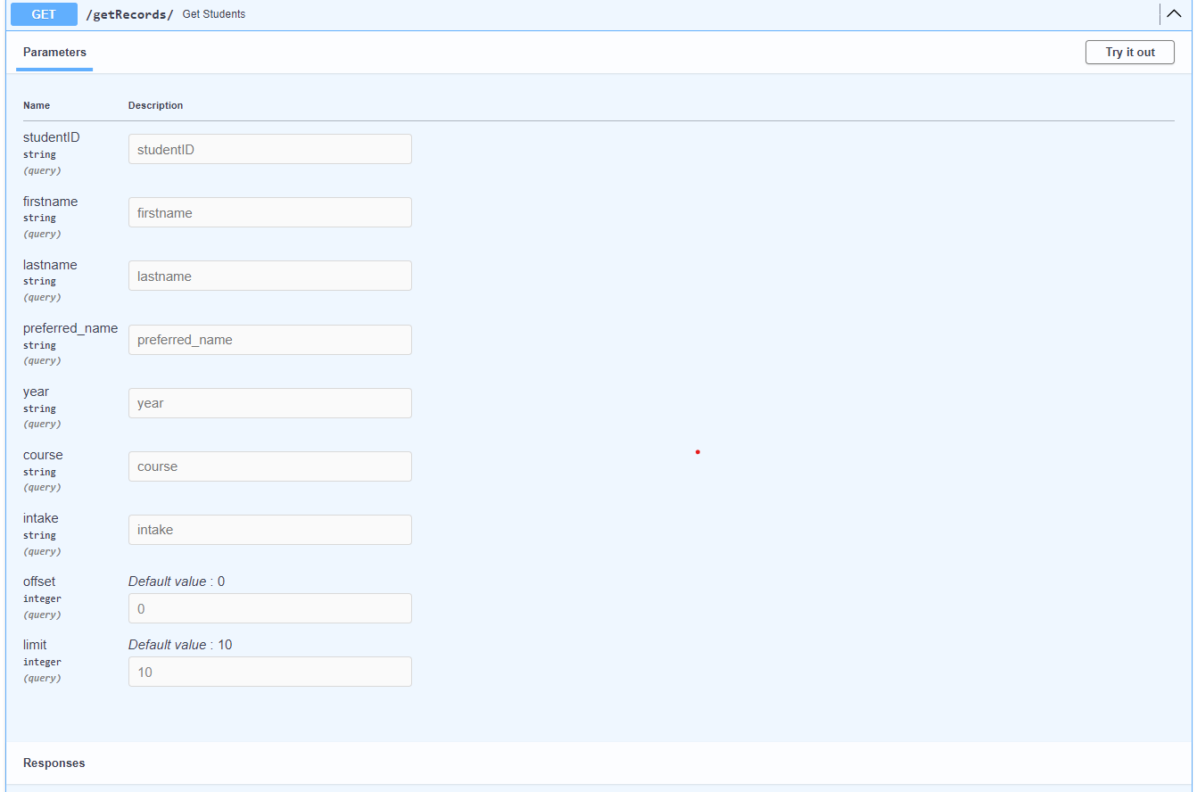

If no records found matching then below response will return
{
"total_count": 0,
"results": []
}

If there are existing records and matched with filtering you will get the response as below which will also provide you with the count to display
Response body
Download
{
"total_count": 5,
"results": [
{
"student_id": 92900217,
"first_name": "winston",
"last_name": "mrs",
"preferred_name": "winston",
"phonetics_selection": "win-ston",
"pronoun": "He/HIm",
"course": "AIGS",
"intake": "Fall",
"year": 2023,
"show": true
},
{
"student_id": 0,
"first_name": "string",
"last_name": "string",
"preferred_name": "string",
"phonetics_selection": "string",
"pronoun": "string",
"course": "STRING",
"intake": "Fall",
"year": 0,
"show": true
},
{
"student_id": 0,
"first_name": "string",
"last_name": "string",
"preferred_name": "string",
"phonetics_selection": "string",
"pronoun": "string",
"course": "STRING",
"intake": "Fall",
"year": 0,
"show": true
},
{
"student_id": 0,
"first_name": "string",
"last_name": "string",
"preferred_name": "string",
"phonetics_selection": "string",
"pronoun": "string",
"course": "STRING",
"intake": "Fall",
"year": 0,
"show": true
},
{
"student_id": 0,
"first_name": "string",
"last_name": "string",
"preferred_name": "string",
"phonetics_selection": "string",
"pronoun": "string",
"course": "STRING",
"intake": "Fall",
"year": 0,
"show": true
}
]
}
http://127.0.0.1:8081/update

{
"student_id": 0,
"first_name": "string",
"pronoun": "string",
"last_name": "string",
"preferred_name": "string",
"course": "string",
"intake": "Fall",
"year": 0,
"phonetics_selection": "string"
}

If records updated successfully you will receive below response
Response body
Download
{
"status": "success",
"message": "updated record successfully"
}
If there is any error during the update below will be the response
return {"message": e,
"status": "failed"}

“e” in the message will have the error

http://127.0.0.1:8081/userfeedback

Request
{
"student_id": 0,
"userfeedback": "string"
}

Response
Response body
Download
{
"status": "success",
"message": ""
}

If there is any error then you will receive below response
Response body
Download
{
"status": "failed",
"message": "incorrect details received or feedback for this user is already exist."
}

Request URL
http://127.0.0.1:8081/deleterecord

{"student_id": 0
}
Response body
{
"status": "success",
"message": "Deleted record successfully"
}

If there is no record then you will get below response
Response body
Download
{
"status": "success",
"message": "Record with 0 doesn't exist in the system "
http://127.0.0.1:8081/getaudiophonetics

Request body
application/json
- Example Value
- Schema
{
"phonetics_name": "wins-ton"
}
}
Response will stream the audio directly, just return the steam.

Below is the code that might help you see what we are sending
HTML
<audio id="audioPlayer" controls>
Your browser does not support the audio element.
</audio>

Javascript/typescript
const audioPlayer = document.getElementById('audioPlayer');

fetch('/your-audio-endpoint')
.then(response => response.blob())
.then(blob => {
const objectURL = URL.createObjectURL(blob);
audioPlayer.src = objectURL;
})
.catch(error => console.error('Error fetching audio:', error));

If any error occurred during the audio fetch
{
"status": "failed",
"message": "unable to get audio at this moment"
}

http://127.0.0.1:8081/getaudio

Request body
application/json
- Example Value
- Schema
{
"preferred_name": "winston"
}
Response will stream the audio directly, just return the steam.

Below is the code that might help you see what we are sending
HTML
<audio id="audioPlayer" controls>
Your browser does not support the audio element.
</audio>

Javascript/typescript
const audioPlayer = document.getElementById('audioPlayer');

fetch('/your-audio-endpoint')
.then(response => response.blob())
.then(blob => {
const objectURL = URL.createObjectURL(blob);
audioPlayer.src = objectURL;
})
.catch(error => console.error('Error fetching audio:', error));
}
{
"status": "failed",
"message": "unable to get audio at this moment"
}

